BOARD OF TRUSTEES
McHENRY COUNTY COLLEGE DISTRICT #528

Tuesday, May 19, 2026  3:00 p.m. |  | MCC Board Room, A217  8900 US Highway 14  Crystal Lake, IL 60012

FINANCE AND AUDIT COMMITTEE MEETING

- Call to Order
- Roll Call
- Acceptance of Agenda
- Open for Recognition of Visitors and Public Comments
- FY 2027 Proposed Budget Discussion
- Comments by Committee Members
- Adjournment
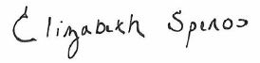
Elizabeth Speros
Chair

