BOARD OF TRUSTEES
McHENRY COUNTY COLLEGE DISTRICT #528

Thursday, April 23, 2026  First Meeting of the Newly Organized Board  Following the Organizational Meeting |  | MCC Board Room, A217  8900 U.S. Highway 14  Crystal Lake, IL 60012

AGENDA

1. Call to Order
2. Roll Call
3. Acceptance of Agenda
4. Open for Public Comments
5. Other Business
6. Summary Comments by Board Members
7. Adjournment
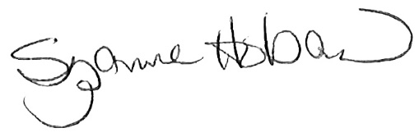
Suzanne Hoban
Chair

