BOARD OF TRUSTEES
McHENRY COUNTY COLLEGE DISTRICT #528

Thursday, April 23, 2026  Organizational Meeting  Following the Final Meeting  of the Retiring Board |  | MCC Board Room, A217  8900 U.S. Highway 14  Crystal Lake, IL 60012

AGENDA

- Call To Order
- Roll Call
- Acceptance Of Agenda
- Open For Public Comments
- Installation Of Student Trustee, Ms. Dagne Leiva
- Election Of Chair, Vice Chair and Secretary
- Motion To Continue Rules, Regulations and Policies
- Motion To Set Board Meeting Dates and Times
- Appointment of Treasurer
- Appointment of Board Attorney
- Appointment of Committee Structure
- Appointment of Foundation Liaison and Alternate
- Appointment of ICCTA Representative and Alternate
- Adjournment
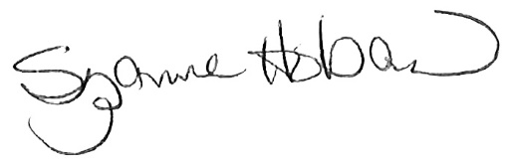
Suzanne Hoban
Chair

