Board of Trustees
McHenry County College District #528

Tuesday, April 14, 2026  6:00 p.m. |  | MCC Board Room, A217  8900 US Highway 14  Crystal Lake, IL 60012

Committee Of the Whole Meeting

Agenda

- Call to Order
- Roll Call
- Acceptance of Agenda
- Acceptance of Minutes: Committee of the Whole, March 10, 2026
- Open for Recognition of Public Comments
- President’s Report
- Preliminary March Financial Statements: Mr. Bob Tenuta
- Future Agenda Items/Summary Comments by Board Members
- Closed Session
  - 120/2(c) Exception #1, Personnel
  - 120/2(c) Exception #21, Review of Closed Session Minutes
  - Other matters as pertain to the exceptions of the Open Meetings Act

- Acceptance of Closed Session Minutes of January 13, 2026, Committee of the Whole Meeting

- Adjournment
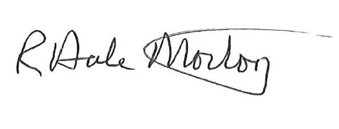
Dale Morton
Chair

